Table of Contents
1. Activity 1: Database Design Challenge 2
1.1 Application Selected: Travel Booking Platform 2
1.2 Main Data Entities 2
1.3 Database Choice 2
1.4 Justification for Database Choice 2
1.5 MongoDB Data Model 2
1.6 MongoDB Example Query 3
1.7 Neo4j Graph Model 3
1.8 Neo4j Example Query 4
1.9 Use Cases 4
2. Activity 2: Collaborative Query Development 5
2.1 Dataset Selected: Customer Purchase Behaviour Dataset 5
2.3 Tools Used 5
2.4 MongoDB Implementation 5
2.4.1 MongoDB Database and Collection 5
2.4.2 MongoDB Data Structure 5
2.5 MongoDB Queries and Results 7
2.5.1 Query 1: Find Customers from London 7
2.5.2 Query 2: Find Customers Who Bought Electronics Products 7
2.5.3 Query 3: Find Customers Who Prefer Gaming 8
2.5.4 Query 4: Find Total Spending by Each Customer 9
2.5.5 Query 5: Find Most Purchased Product Categories 10
2.6 Neo4j Implementation 12
2.6.1 Neo4j Graph Model 12
2.6.2 Neo4j Nodes 13
2.7 Neo4j Queries and Results 14
2.7.1 Query 1: Find Customers Who Prefer the Same Category 14
2.7.2 Query 2: Find Products Bought by Each Customer 14
2.7.3 Query 3: Identify Customer Clusters 15
2.7.4 Query 4: Recommend Products Based on Shared Preferences 16
2.8 Comparison of MongoDB and Neo4j Findings 18
2.9 Strengths and Limitations 18
2.9.1 Strengths of MongoDB 18
2.9.2 Limitations of MongoDB 18
2.9.3 Strengths of Neo4j 18
2.9.4 Limitations of Neo4j 19
2.10 Final Comparison Statement 19
3. Activity 3: Graph Query 19
3.1 Dataset Selected: University Courses and Programmes Graph 19
3.2 Main Data Entities 19
3.3 Neo4j Graph Model 20
3.4 Cypher Queries and Results 21
3.4.1 Query 1: Find All Courses in BSc Computer Science 21
3.4.2 Query 2: Find Courses Completed by Aisha Khan 22
3.4.3 Query 3: Find Courses Aisha Khan Can Take Based on Prerequisites 23
3.4.4 Query 4: Find Prerequisite for Machine Learning 24
3.4.5 Query 5: Find Tutor for Each Course 25
3.4.6 Query 6: Identify the Most Connected Tutor 26
3.4.7 Query 7: Find Courses Offered by Each Department 27
3.5 Summary of Findings 27
3.6 Strengths of Neo4j for This Activity 28

1. Activity 1: Database Design Challenge

1.1 Application Selected: Travel Booking Platform

1.2 Main Data Entities
Users
Hotels
Flights
Destinations
Bookings
Reviews
Payments
Travel Preferences

1.3 Database Choice
For this application, a hybrid approach using both MongoDB and Neo4j is suitable.

1.4 Justification for Database Choice
MongoDB can store document-based data, such as user profiles, hotel and travel details, reservations, reviews, and payment records.
Relationship-based data, such as trip schedules, comparable users, lodging ideas, places visited, and user preferences, can be managed using Neo4j.
It is reasonable to use both MongoDB and Neo4j since a travel booking site needs both flexible data storage and relationship-based searches.

1.5 MongoDB Data Model
MongoDB can store data such as users, hotels, bookings, reviews, and payments in document format.
Example user document:
{
"userId": "U101",
"name": "Aisha Khan",
"email": "aisha@example.com",
"preferences": {
"budget": "medium",
"preferredDestinations": ["Paris", "Rome"],
"travelStyle": "family"
},
"bookings": [
{
"bookingId": "B501",
"hotel": "Paris Central Hotel",
"checkIn": "2026-07-12",
"checkOut": "2026-07-18",
"status": "confirmed"
}
]
}

1.6 MongoDB Example Query
db.users.find({
"preferences.preferredDestinations": "Paris"
})

This query finds users who are interested in travelling to Paris.

1.7 Neo4j Graph Model
Neo4j can represent relationships between users, destinations, hotels, and preferences.
Example graph structure:

(User)-[:BOOKED]->(Hotel)
(User)-[:VISITED]->(Destination)
(User)-[:REVIEWED]->(Hotel)
(Destination)-[:CONNECTED_TO]->(Destination)
(User)-[:HAS_PREFERENCE]->(TravelStyle)

1.8 Neo4j Example Query
MATCH (u:User)-[:VISITED]->(d:Destination)<-[:VISITED]-(other:User),
(other)-[:VISITED]->(recommended:Destination)
WHERE u.name = "Aisha Khan"
AND NOT (u)-[:VISITED]->(recommended)
RETURN recommended.name AS Recommendation, COUNT(*) AS Score
ORDER BY Score DESC

This query recommends destinations based on places visited by similar users.

1.9 Use Cases
Users can search hotels and flights.
Users can make bookings.
Users can view booking history.
Users can write reviews.
The system can recommend destinations.
The system can find connected travel locations.
The system can analyze user travel preferences.

2. Activity 2: Collaborative Query Development

2.1 Dataset Selected: Customer Purchase Behaviour Dataset
A Customer Purchase Behavior Dataset was chosen for this job. Neo4j and MongoDB both used the same dataset.
Customer profiles, preferences, product information, product categories, orders, and purchase records are all included in the collection.2.2 Main Data Entities
The main data entities used in this activity are:
- Customers
- Products
- Categories
- Orders
- Preferences

2.3 Tools Used
Tool | Purpose
MongoDB Atlas | To store and analyze customer purchase data in document format
Neo4j | To represent and analyze relationships using a graph model

2.4 MongoDB Implementation

2.4.1 MongoDB Database and Collection
In MongoDB Atlas, a database and collection were created for the customer purchase dataset.
Item | Name
Database | customerPurchaseDB
Collection | customers
Number of Documents | 4

2.4.2 MongoDB Data Structure
MongoDB stores the dataset in document format. Each customer document contains customer information, preferences, and order details.
Example document structure:
{
"customerId": "C101",
"name": "Aisha Khan",
"location": "London",
"preferences": ["Electronics", "Accessories"],
"orders": [
{
"orderId": "O501",
"date": "2026-05-10",
"items": [
{
"productId": "P201",
"productName": "Wireless Mouse",
"category": "Electronics",
"quantity": 1,
"price": 25
}
],
"paymentMethod": "Card"
}
]
}

MongoDB is suitable for this type of data because customer details, preferences, and orders can be stored together in one flexible document.

2.5 MongoDB Queries and Results

2.5.1 Query 1: Find Customers from London
MongoDB Query:
{
"location": "London"
}
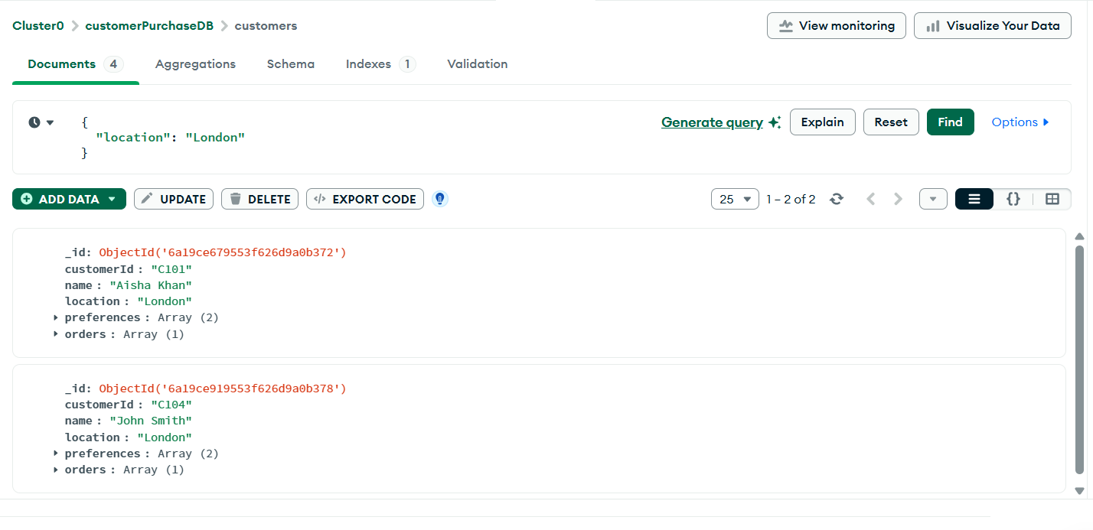
Result:
Customer ID | Customer Name | Location
C101 | Aisha Khan | London
C104 | John Smith | London

Finding:
The query shows that Aisha Khan and John Smith are customers from London.

2.5.2 Query 2: Find Customers Who Bought Electronics Products
MongoDB Query:
{
"orders.items.category": "Electronics"
}
Result:
Customer ID | Customer Name | Product Category
C101 | Aisha Khan | Electronics
C104 | John Smith | Electronics

Finding:
The result shows that Aisha Khan and John Smith bought products from the Electronics category.

2.5.3 Query 3: Find Customers Who Prefer Gaming
MongoDB Query:
{
"preferences": "Gaming"
}
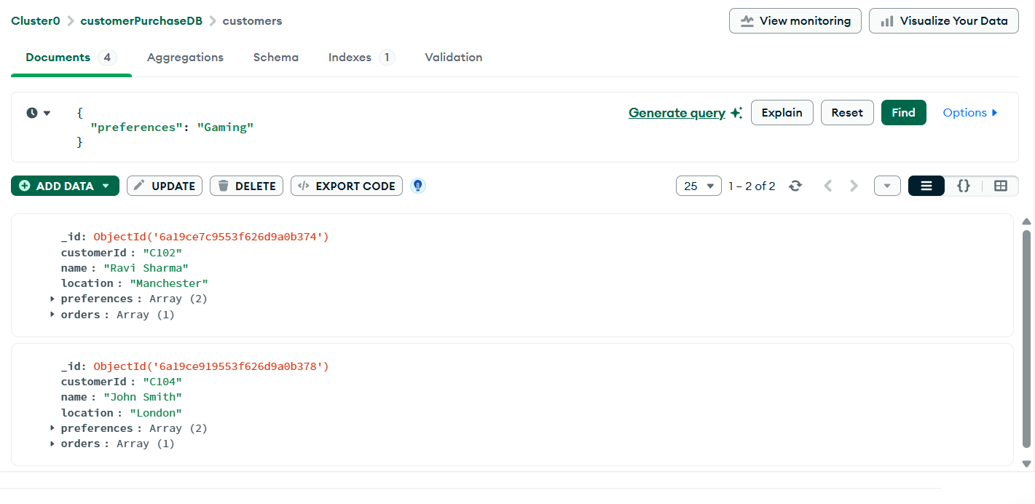
Result:
Customer ID | Customer Name | Preference
C102 | Ravi Sharma | Gaming
C104 | John Smith | Gaming

Finding:
The result shows that Ravi Sharma and John Smith prefer Gaming.

2.5.4 Query 4: Find Total Spending by Each Customer
MongoDB Aggregation Query:
[
{
"$unwind": "$orders"
},
{
"$unwind": "$orders.items"
},
{
"$group": {
"_id": "$customerId",
"customerName": {
"$first": "$name"
},
"totalSpent": {
"$sum": {
"$multiply": [
"$orders.items.quantity",
"$orders.items.price"
]
}
}
}
},
{
"$sort": {
"totalSpent": -1
}
}
]
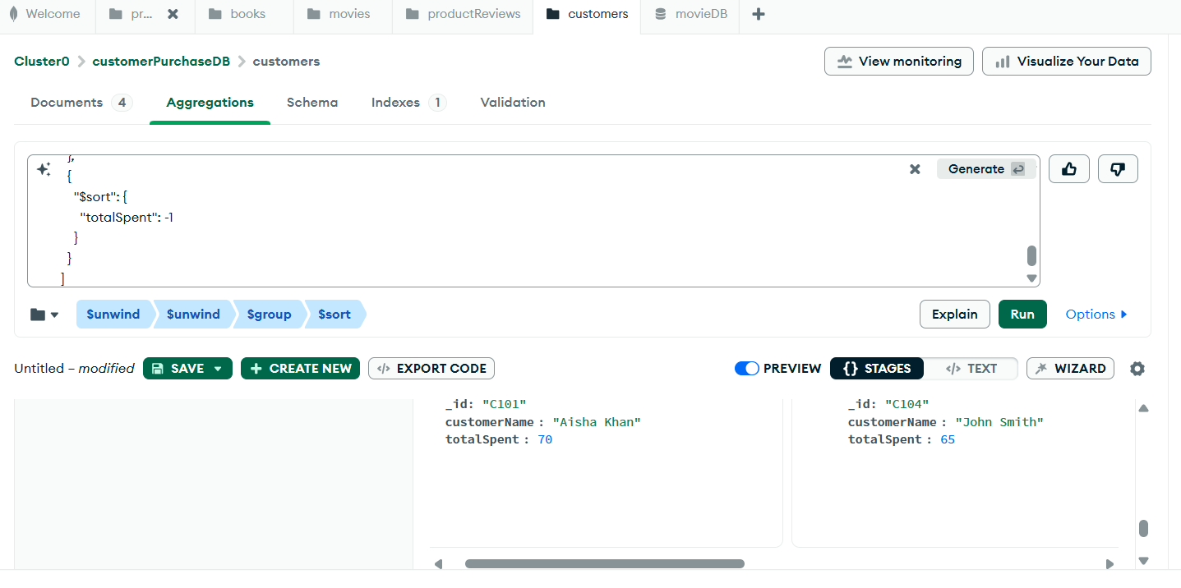
Result:
Customer ID | Customer Name | Total Spent
C101 | Aisha Khan | 70
C104 | John Smith | 65
C102 | Ravi Sharma | 60
C103 | Sara Ali | 60

Finding:
The aggregation result shows that Aisha Khan spent the most, with total spending of 70. John Smith spent 65, while Ravi Sharma and Sara Ali each spent 60.

2.5.5 Query 5: Find Most Purchased Product Categories
MongoDB Aggregation Query:
[
{
"$unwind": "$orders"
},
{
"$unwind": "$orders.items"
},
{
"$group": {
"_id": "$orders.items.category",
"totalQuantity": {
"$sum": "$orders.items.quantity"
}
}
},
{
"$sort": {
"totalQuantity": -1
}
}
]
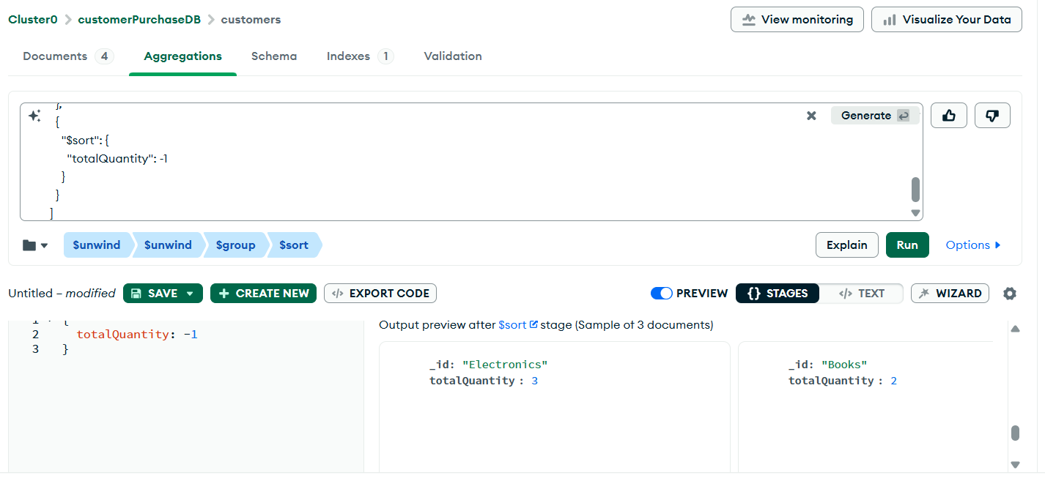
Result:
Product Category | Total Quantity
Electronics | 3
Books | 2
Gaming | 2

Finding:
The most purchased product category is Electronics, with a total quantity of 3. Books and Gaming both have a total quantity of 2.

2.6 Neo4j Implementation

2.6.1 Neo4j Graph Model
In Neo4j, the same dataset was represented as a graph. Customers, products, and categories were created as nodes, while customer actions and preferences were represented as relationships.
The graph contains:
Node Type | Number of Nodes
Customer | 4
Product | 5
Category | 5
Total Nodes | 14

The graph uses these relationships:
(Customer)-[:BOUGHT]->(Product)
(Customer)-[:PREFERS]->(Category)
(Product)-[:BELONGS_TO]->(Category)

Screenshot to include here:
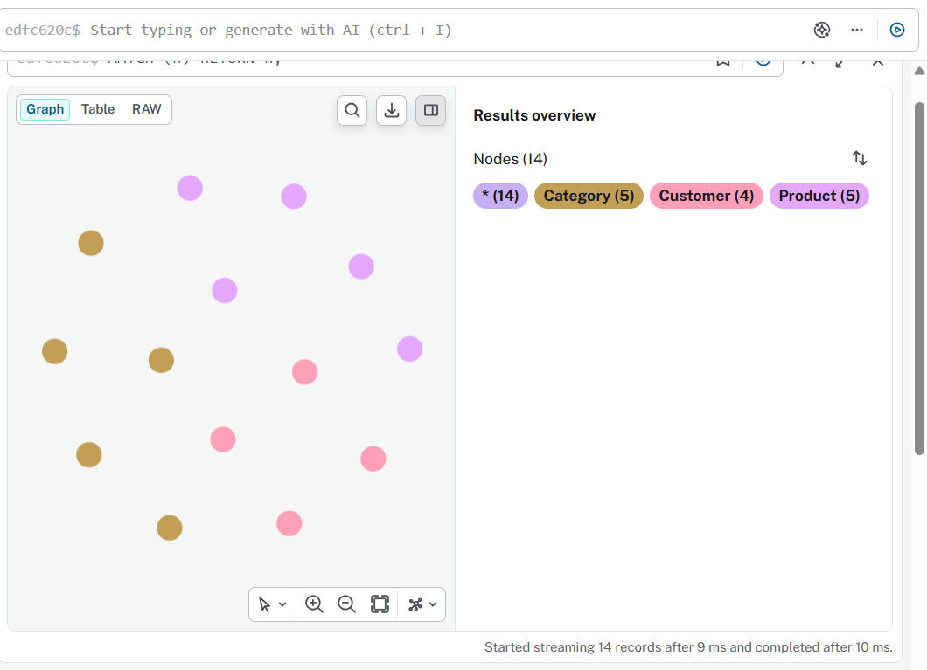

2.6.2 Neo4j Nodes
The Neo4j graph contains the following nodes:
Node Type | Values
Customer | Aisha Khan, Ravi Sharma, Sara Ali, John Smith
Product | Wireless Mouse, Keyboard, Gaming Headset, Database Systems Book, Gaming Mouse
Category | Electronics, Accessories, Gaming, Books, Education

2.7 Neo4j Queries and Results

2.7.1 Query 1: Find Customers Who Prefer the Same Category
Neo4j Query:
MATCH (c1:Customer)-[:PREFERS]->(cat:Category)<-[:PREFERS]-(c2:Customer)
WHERE c1.customerId < c2.customerId
RETURN c1.name AS Customer1, c2.name AS Customer2, cat.name AS SharedPreference;
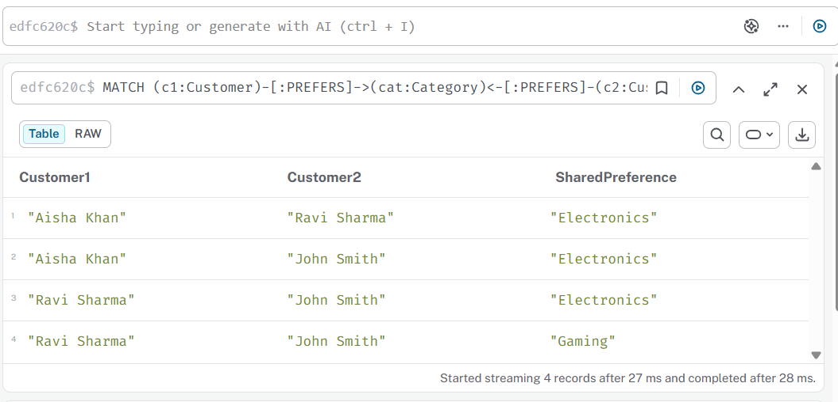
Result:
Customer 1 | Customer 2 | Shared Preference
Aisha Khan | Ravi Sharma | Electronics
Aisha Khan | John Smith | Electronics
Ravi Sharma | John Smith | Electronics
Ravi Sharma | John Smith | Gaming

Finding:
Neo4j shows that Aisha Khan, Ravi Sharma, and John Smith share an interest in Electronics. It also shows that Ravi Sharma and John Smith share an interest in Gaming.

2.7.2 Query 2: Find Products Bought by Each Customer
Neo4j Query:

MATCH (c:Customer)-[:BOUGHT]->(p:Product)
RETURN c.name AS Customer, p.name AS Product, p.price AS Price;
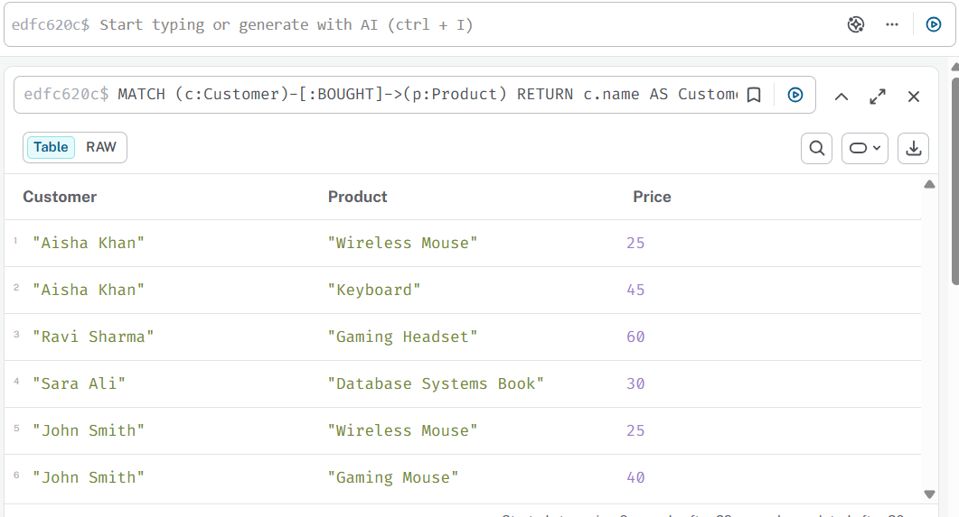
Result:
Customer | Product | Price
Aisha Khan | Wireless Mouse | 25
Aisha Khan | Keyboard | 45
Ravi Sharma | Gaming Headset | 60
Sara Ali | Database Systems Book | 30
John Smith | Wireless Mouse | 25
John Smith | Gaming Mouse | 40

Finding:
The query shows the products bought by each customer. Aisha Khan bought Wireless Mouse and Keyboard. John Smith bought Wireless Mouse and Gaming Mouse.

2.7.3 Query 3: Identify Customer Clusters
Neo4j Query:
MATCH (c:Customer)-[:PREFERS]->(cat:Category)
RETURN cat.name AS Category, collect(c.name) AS CustomerCluster;

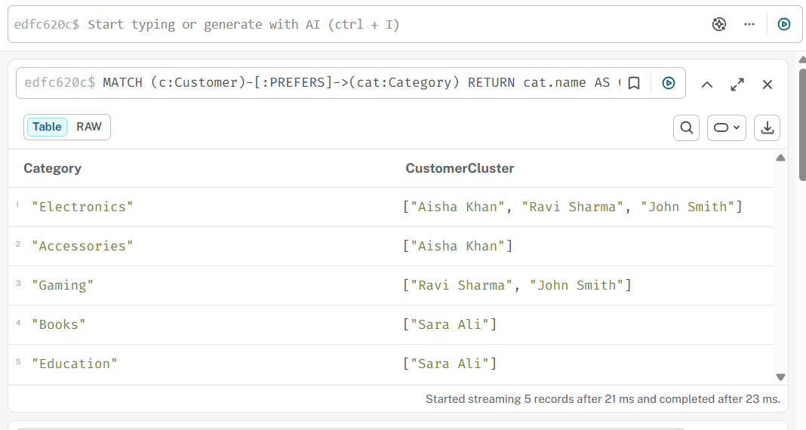
Result:
Category | Customer Cluster
Electronics | Aisha Khan, Ravi Sharma, John Smith
Accessories | Aisha Khan
Gaming | Ravi Sharma, John Smith
Books | Sara Ali
Education | Sara Ali

Finding:
The largest customer cluster is Electronics, which includes Aisha Khan, Ravi Sharma, and John Smith. The Gaming cluster includes Ravi Sharma and John Smith.

2.7.4 Query 4: Recommend Products Based on Shared Preferences
Neo4j Query:
MATCH (c1:Customer)-[:PREFERS]->(cat:Category)<-[:PREFERS]-(c2:Customer),
(c2)-[:BOUGHT]->(p:Product)
WHERE c1 <> c2
AND NOT (c1)-[:BOUGHT]->(p)
RETURN DISTINCT c1.name AS Customer,
p.name AS RecommendedProduct,
cat.name AS SharedPreference;
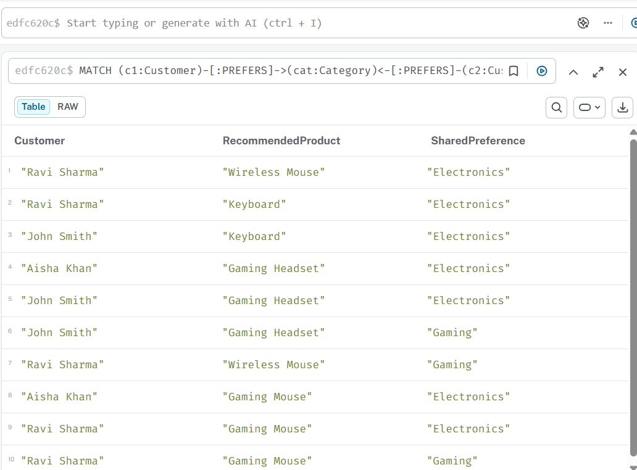
Result examples:
Customer | Recommended Product | Shared Preference
Ravi Sharma | Wireless Mouse | Electronics
Ravi Sharma | Keyboard | Electronics
John Smith | Keyboard | Electronics
Aisha Khan | Gaming Headset | Electronics
John Smith | Gaming Headset | Electronics
John Smith | Gaming Headset | Gaming
Aisha Khan | Gaming Mouse | Electronics
Ravi Sharma | Gaming Mouse | Electronics
Ravi Sharma | Gaming Mouse | Gaming

Finding:
Neo4j recommends products by checking customers who share preferences and identifying products bought by similar customers.

2.8 Comparison of MongoDB and Neo4j Findings
Comparison Point | MongoDB | Neo4j
Data model | Document-based | Graph-based
Data format | Customer documents with embedded orders | Nodes and relationships
Best for | Purchase records and sales analysis | Relationship analysis and recommendations
Query focus | Filtering and aggregation | Relationship traversal
Example finding | Total spending by customer and popular categories | Shared preferences and customer clusters
Strength | Good for analysing purchase patterns | Good for finding connections and recommendations
Limitation | Relationship queries are harder | Transaction-style storage is less direct

2.9 Strengths and Limitations

2.9.1 Strengths of MongoDB
MongoDB is a useful tool for monitoring customer purchasing. One document can hold orders, preferences, and client data. MongoDB may assist with a variety of filtering and aggregating queries, such as locating clients from a location, calculating total spending, and discovering popular product categories.

2.9.2 Limitations of MongoDB
MongoDB is not as well suited for complicated relationship-based queries. For example, compared to Neo4j, MongoDB makes it more difficult to locate consumer clusters or offer products based on shared tastes.

2.9.3 Strengths of Neo4j
Neo4j is a powerful relationship analysis tool. It effectively displays the relationships between customers, products, and categories. Neo4j supports shared preferences, recommendation patterns, and consumer clusters.

2.9.4 Limitations of Neo4j
When it comes to storing big transaction-style records, Neo4j is less easy. Relationship analysis gains more from it than standard document-based storage.

2.10 Final Comparison Statement
Both MongoDB and Neo4j exploited the same consumer purchase dataset, but they yielded various sorts of insights.
MongoDB performed better when it comes to examining purchase activity, including customer location, product category purchases, overall spending, and most purchased categories.
Neo4j was superior for relationship-driven analysis, such as identifying customers with similar tastes, customer clusters, and product recommendations.
As a result, MongoDB is better fit for document-based purchase data, while Neo4j is more appropriate for graph-based relationship analysis.

3. Activity 3: Graph Query

3.1 Dataset Selected: University Courses and Programmes Graph
The dataset for this experiment was a University Courses and Programs Graph. This Neo4j-created dataset comprises students, courses, programs, tutors, departments, and requirements.
The purpose of this exercise is to build Cypher queries that answer graph-based inquiries, including identifying the most connected teacher and working out which courses a student can enroll in depending on requirements.

3.2 Main Data Entities
The main data entities used in this graph are:
- Students
- Courses
- Programmes
- Tutors
- Departments
- Prerequisites

3.3 Neo4j Graph Model
The graph was created in Neo4j using nodes and relationships.
The graph contains:
Node Type | Number of Nodes
Student | 3
Programme | 2
Course | 6
Tutor | 3
Department | 2
Total Nodes | 16

The graph also contains 36 relationships.
The main relationship types are:
(Student)-[:ENROLLED_IN]->(Programme)
(Programme)-[:CONTAINS]->(Course)
(Student)-[:COMPLETED]->(Course)
(Course)-[:HAS_PREREQUISITE]->(Course)
(Tutor)-[:TEACHES]->(Course)
(Tutor)-[:BELONGS_TO]->(Department)
(Course)-[:OFFERED_BY]->(Department)
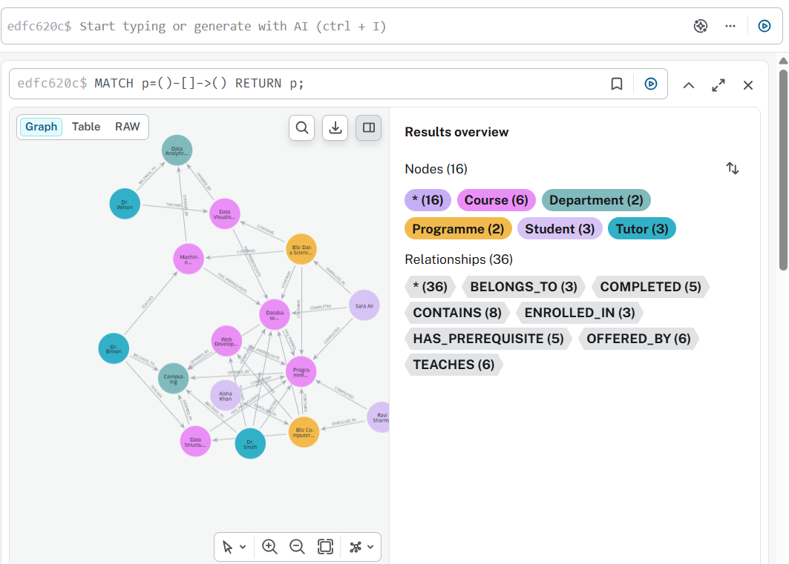
Finding:
The relationships between departments, tutors, programs, courses, and students are represented in the graph. It also illustrates the required interconnections between courses and the instructional connections between instructors and courses.

3.4 Cypher Queries and Results

3.4.1 Query 1: Find All Courses in BSc Computer Science
Challenge:
Find all courses included in the BSc Computer Science programme.
Cypher Query:
MATCH (p:Programme {name: "BSc Computer Science"})-[:CONTAINS]->(c:Course)
RETURN p.name AS Programme, c.name AS Course;

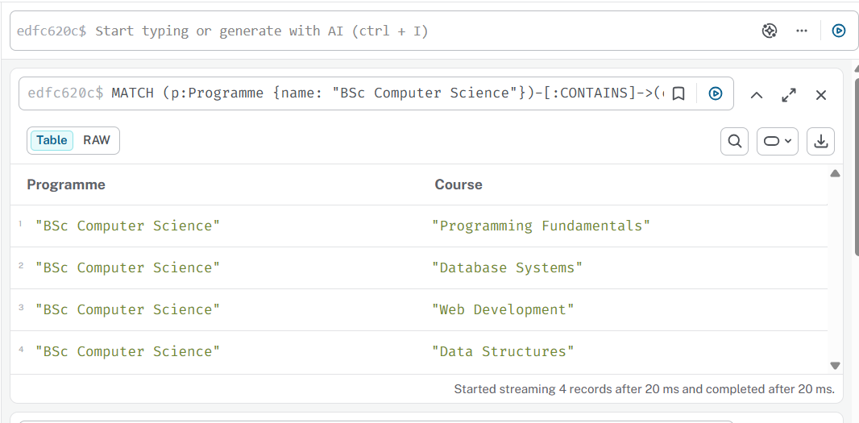
Result:
Programme | Course
BSc Computer Science | Programming Fundamentals
BSc Computer Science | Database Systems
BSc Computer Science | Web Development
BSc Computer Science | Data Structures

Finding:
The BSc Computer Science programme contains four courses: Programming Fundamentals, Database Systems, Web Development, and Data Structures.

3.4.2 Query 2: Find Courses Completed by Aisha Khan
Challenge:
Find all courses completed by Aisha Khan.
Cypher Query:
MATCH (s:Student {name: "Aisha Khan"})-[:COMPLETED]->(c:Course)
RETURN s.name AS Student, c.name AS CompletedCourse;
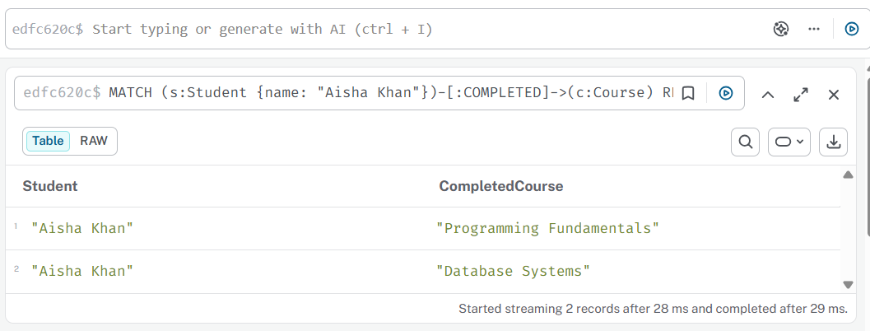
Result:
Student | Completed Course
Aisha Khan | Programming Fundamentals
Aisha Khan | Database Systems

Finding:
Aisha Khan has completed Programming Fundamentals and Database Systems.

3.4.3 Query 3: Find Courses Aisha Khan Can Take Based on Prerequisites
Challenge:
Find which courses Aisha Khan can take based on completed prerequisites.
Cypher Query:
MATCH (s:Student {name: "Aisha Khan"})-[:ENROLLED_IN]->(p:Programme)-[:CONTAINS]->(course:Course)
WHERE NOT (s)-[:COMPLETED]->(course)
AND ALL(prereq IN [(course)-[:HAS_PREREQUISITE]->(pre:Course) | pre]
WHERE (s)-[:COMPLETED]->(prereq))
RETURN s.name AS Student, course.name AS CourseCanTake;

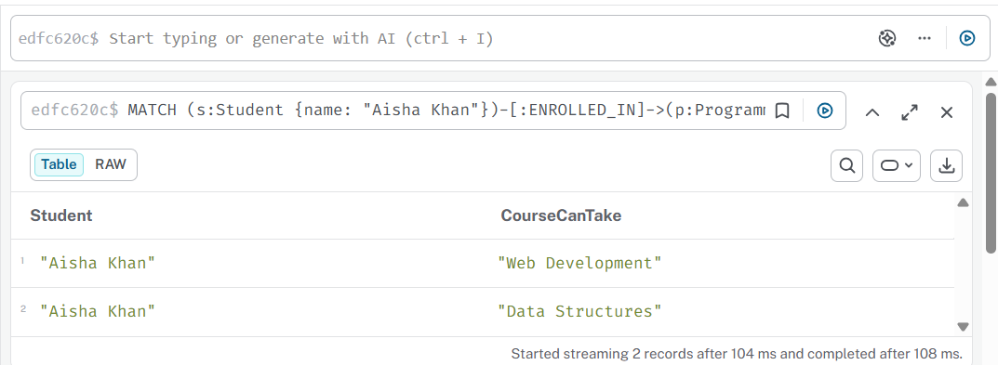
Result:
Student | Course Can Take
Aisha Khan | Web Development
Aisha Khan | Data Structures

Finding:
Aisha Khan can take Web Development and Data Structures because she has completed the required prerequisite course, Programming Fundamentals.

3.4.4 Query 4: Find Prerequisite for Machine Learning
Challenge:
Find the prerequisite course required for Machine Learning.
Cypher Query:
MATCH (c:Course {name: "Machine Learning"})-[:HAS_PREREQUISITE]->(pre:Course)
RETURN c.name AS Course, pre.name AS Prerequisite;
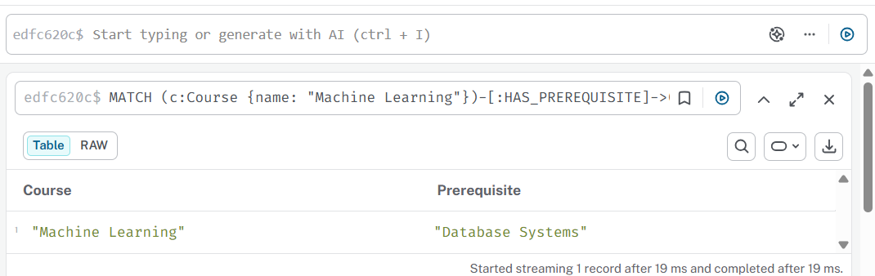
Result:
Course | Prerequisite
Machine Learning | Database Systems

Finding:
The prerequisite for Machine Learning is Database Systems.

3.4.5 Query 5: Find Tutor for Each Course
Challenge:
Find which tutor teaches each course.
Cypher Query:
MATCH (t:Tutor)-[:TEACHES]->(c:Course)
RETURN t.name AS Tutor, c.name AS Course
ORDER BY t.name;
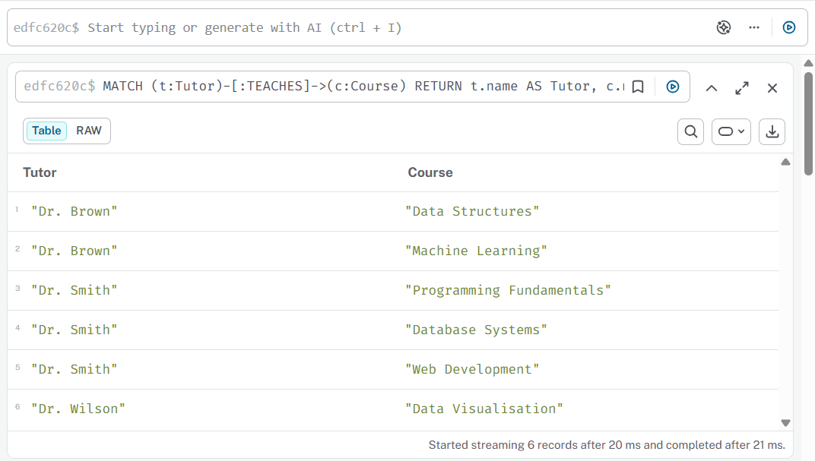
Result:

Tutor | Course
Dr. Brown | Data Structures
Dr. Brown | Machine Learning
Dr. Smith | Programming Fundamentals
Dr. Smith | Database Systems
Dr. Smith | Web Development
Dr. Wilson | Data Visualisation

Finding:
The query shows the tutor responsible for each course. Dr. Smith teaches three courses, Dr. Brown teaches two courses, and Dr. Wilson teaches one course.

3.4.6 Query 6: Identify the Most Connected Tutor
Challenge:
Identify the tutor who teaches the highest number of courses.
Cypher Query:
MATCH (t:Tutor)-[:TEACHES]->(c:Course)
RETURN t.name AS Tutor, count(c) AS NumberOfCourses
ORDER BY NumberOfCourses DESC
LIMIT 1;
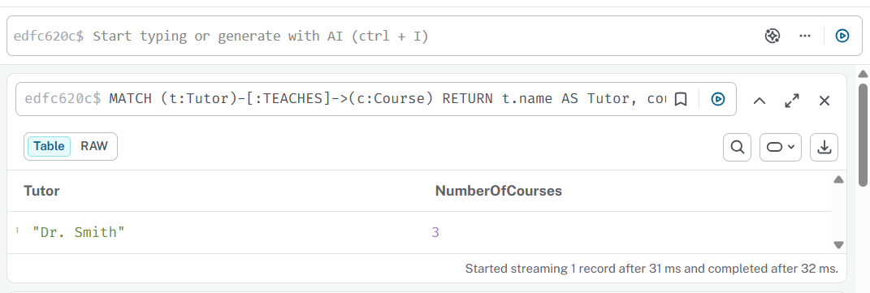
Result:
Tutor | Number of Courses
Dr. Smith | 3

Finding:
The most connected tutor is Dr. Smith, because Dr. Smith teaches three courses.

3.4.7 Query 7: Find Courses Offered by Each Department
Challenge:
Find which courses are offered by each department.
Cypher Query:
MATCH (c:Course)-[:OFFERED_BY]->(d:Department)
RETURN d.name AS Department, collect(c.name) AS Courses;
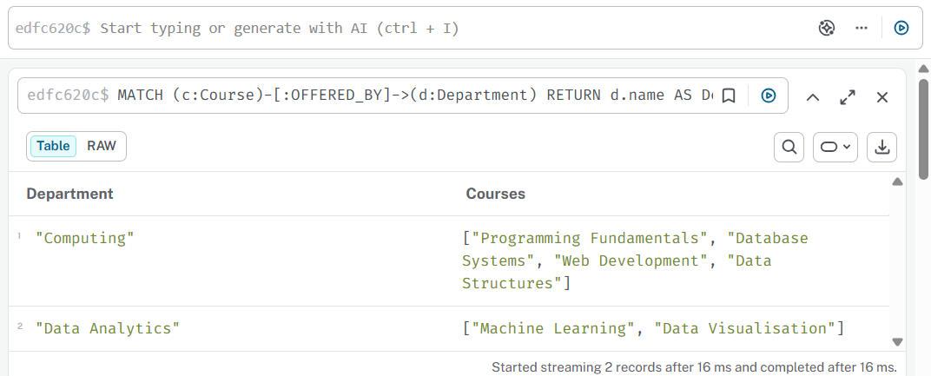
Result:
Department | Courses
Computing | Programming Fundamentals, Database Systems, Web Development, Data Structures
Data Analytics | Machine Learning, Data Visualisation

Finding:
The Computing department offers four courses, while the Data Analytics department offers two courses.

3.5 Summary of Findings
Query Challenge | Main Finding
Find courses in BSc Computer Science | The programme contains four courses
Find courses completed by Aisha Khan | Aisha completed Programming Fundamentals and Database Systems
Find courses Aisha Khan can take | Aisha can take Web Development and Data Structures
Find prerequisite for Machine Learning | Machine Learning requires Database Systems
Find tutor for each course | Tutors are connected to the courses they teach
Identify most connected tutor | Dr. Smith is the most connected tutor
Find courses by department | Computing offers four courses and Data Analytics offers two

3.6 Strengths of Neo4j for This Activity
Due to the various relationships observed in university course data, Neo4j is suited for this purpose. Programs comprise courses, students finish courses, departments offer courses, tutors educate courses, and students are related to programs.
Cypher queries make it easy to follow these relationships. locating prerequisite-based course possibilities, locating tutor associations, and studying the links between courses and university programs are all made easier with Neo4j.

